**TOY Emulator User Manual**

**Running the program**

Double click on TOYEmulator.jar to run the program.



You can also run it by typing java -jar TOYEmulator.jar in the command line. You should have the [Java Runtime Environment](https://www.oracle.com/java/technologies/downloads/) installed, with a version at of at least 17.

**Opening a TOY file**

Once the software is running, you may want to open a TOY file to run it. You can do this by navigating to the “Open” button in the menu bar as shown.

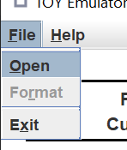

This will bring up a dialog asking you to select a file to run.

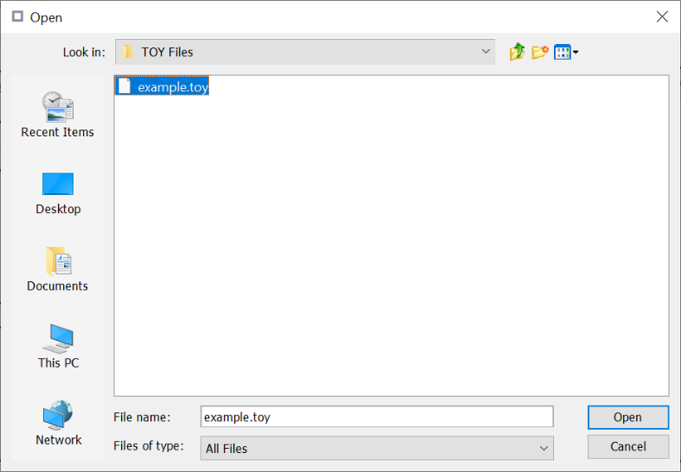

You can select any file, but an error message will pop up if the selected file is not a valid TOY program. Reasons for this include not having any TOY code, having lines numbered out of order or having duplicate line numbers.

Keep in mind that while a program may be considered valid at this point, it may produce errors at runtime.

**Running a TOY file**

Once the program has been loaded successfully, its first instruction should be displaying in the info box at the top. You can click the “Run” button to begin executing the program.

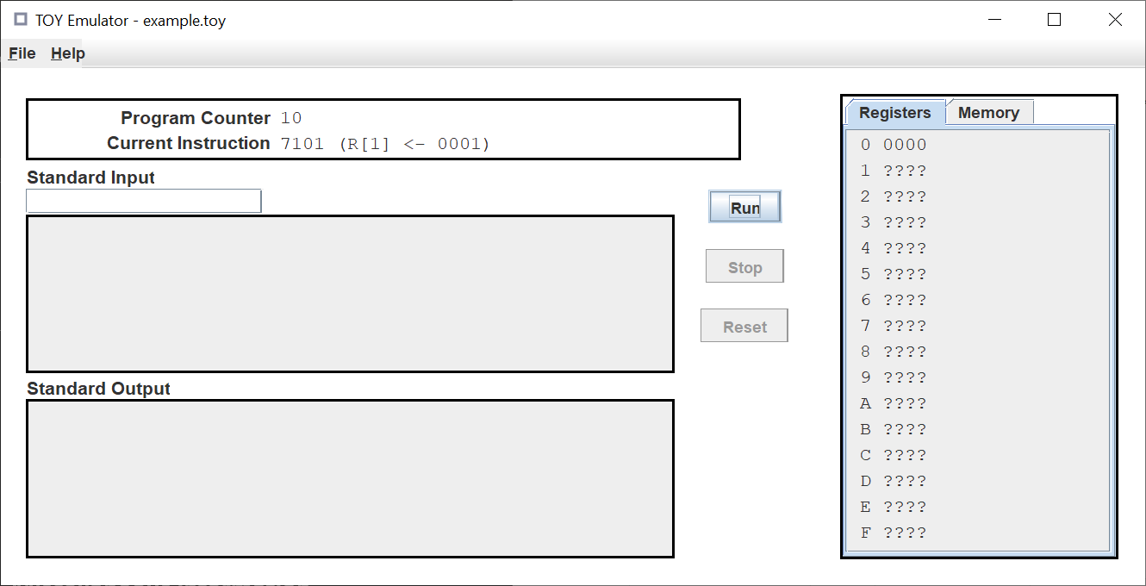

If you wish to stop execution at any time, you can press the “Stop” button. This will only halt the program temporarily, you can still run it again after.

Once the program has stopped, you can press the “Reset” button to reset it. This will clear all the registers, standard input and standard output, and reset the program counter.

Your program may interact with standard input and standard output. If a value is sent to standard output, it will appear in the box labelled “Standard Output” in the bottom left.

You can enter values into standard input at any time using the text field labelled “Standard Input”. Only hexadecimal digits are accepted. Make sure to press the enter key to send your entered value to standard input.

If your program requires a value from standard input and there is nothing there, it will halt. You can run it again after you have entered something.

If your program causes a runtime error, a dialog box will pop up explaining the problem and the line it occurred at.

**Miscellaneous information**

You can view either the registers or the memory by clicking on the tabs in the box on the right. You can also switch between them using the left and right arrow keys, if they are selected.

You can open this document at any time by navigating to the “Open User Manual” button in the menu bar.

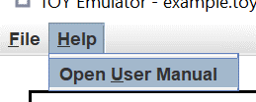

You can format the loaded program by pressing the “Format” button. A dialog box will appear if this is successful.

This will generate and add comments to any line with valid TOY code.

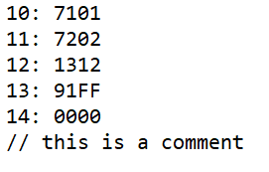

You can exit the application by pressing the “Exit” button.

